

*This exercise is based on an excerpt of Codex document – CX/CF25/18/18 developed in May 2025 and related to the Analysis of the Occurrence Data in Spice Mixtures.*

*The Entire Document is provided for your reference. However, some relevant extracts were also included in a separate document as the basis for this exercise.*

# Brief Background

The objective of the standard development followed by Codex relates to the possible consideration for a standard for mixed herbs / spices.

In reading the document provided and analyzing the information, please attempt to answer the following questions:

# Question 1

A Total of 14805 Data points were found in the GEMS Food Data base corresponding to occurrence values for Pb in food commodities labelled as herbs, spices and condiments.

Corresponding to 45 food items – only a total of 5,250 data points were retained.

Why?

Click or tap here to enter text.

# Question 2

Extract the information related to the key parameters of the Methods of Analysis used for Lead in food and reported in the Database.

Can you comment on the values?

Click or tap here to enter text.

# Question 3

Data analysis of the Lead occurrence:

Keeping in mind that Codex is aiming for a possible ML at 2 ppm for Pb in mixed spices and examining the tables provided Table 1 and 2 for the data analysis – Can you have an initial comment on the achievability of the 2 ppm level?

Click or tap here to enter text.

# Question 4

How can you characterize the change in rejection rate from a hypothetical ML set at 1 ppm versus a ML set at 2 ppm? Comment.

Click or tap here to enter text.

# Question 5

Fill the table provided by extracting and tabulating the relevant information on consumption data:

|  |  |  |
| --- | --- | --- |
|  | Mean consumption in g/day | P95 consumption in g/day |
| Children (20 kg) |  |  |
| Adults (84 kg) |  |  |

# Question 6

The mean value of occurrence for lead in mixtures of spices was found to be 0.6 ppm.

When we impose an ML at 2 ppm and 1 ppm the mean changes to 0.21 ppm and 0.17 respectively.

Considering consumption values provided in the table above:

1. Estimate the intake (exposure) to lead for adults and children, considering the mean Pb values for consumption levels of spice mixtures set at the mean level and at the P95 for both children and adults.

Click or tap here to enter text.

1. Discuss the reduction in exposure noticed through only the contribution to Spice Mixtures for MLs set at 2 ppm and 1 ppm and the relevance of such risk management decision.

Discuss the decision to impose a Maximum Level, considering the current estimation of rejection rates, based on reported food occurrence data:

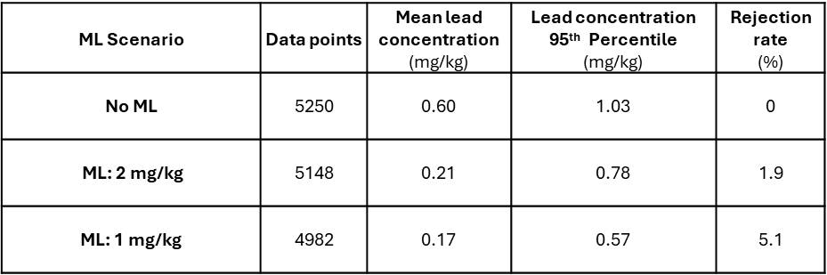

Click or tap here to enter text.