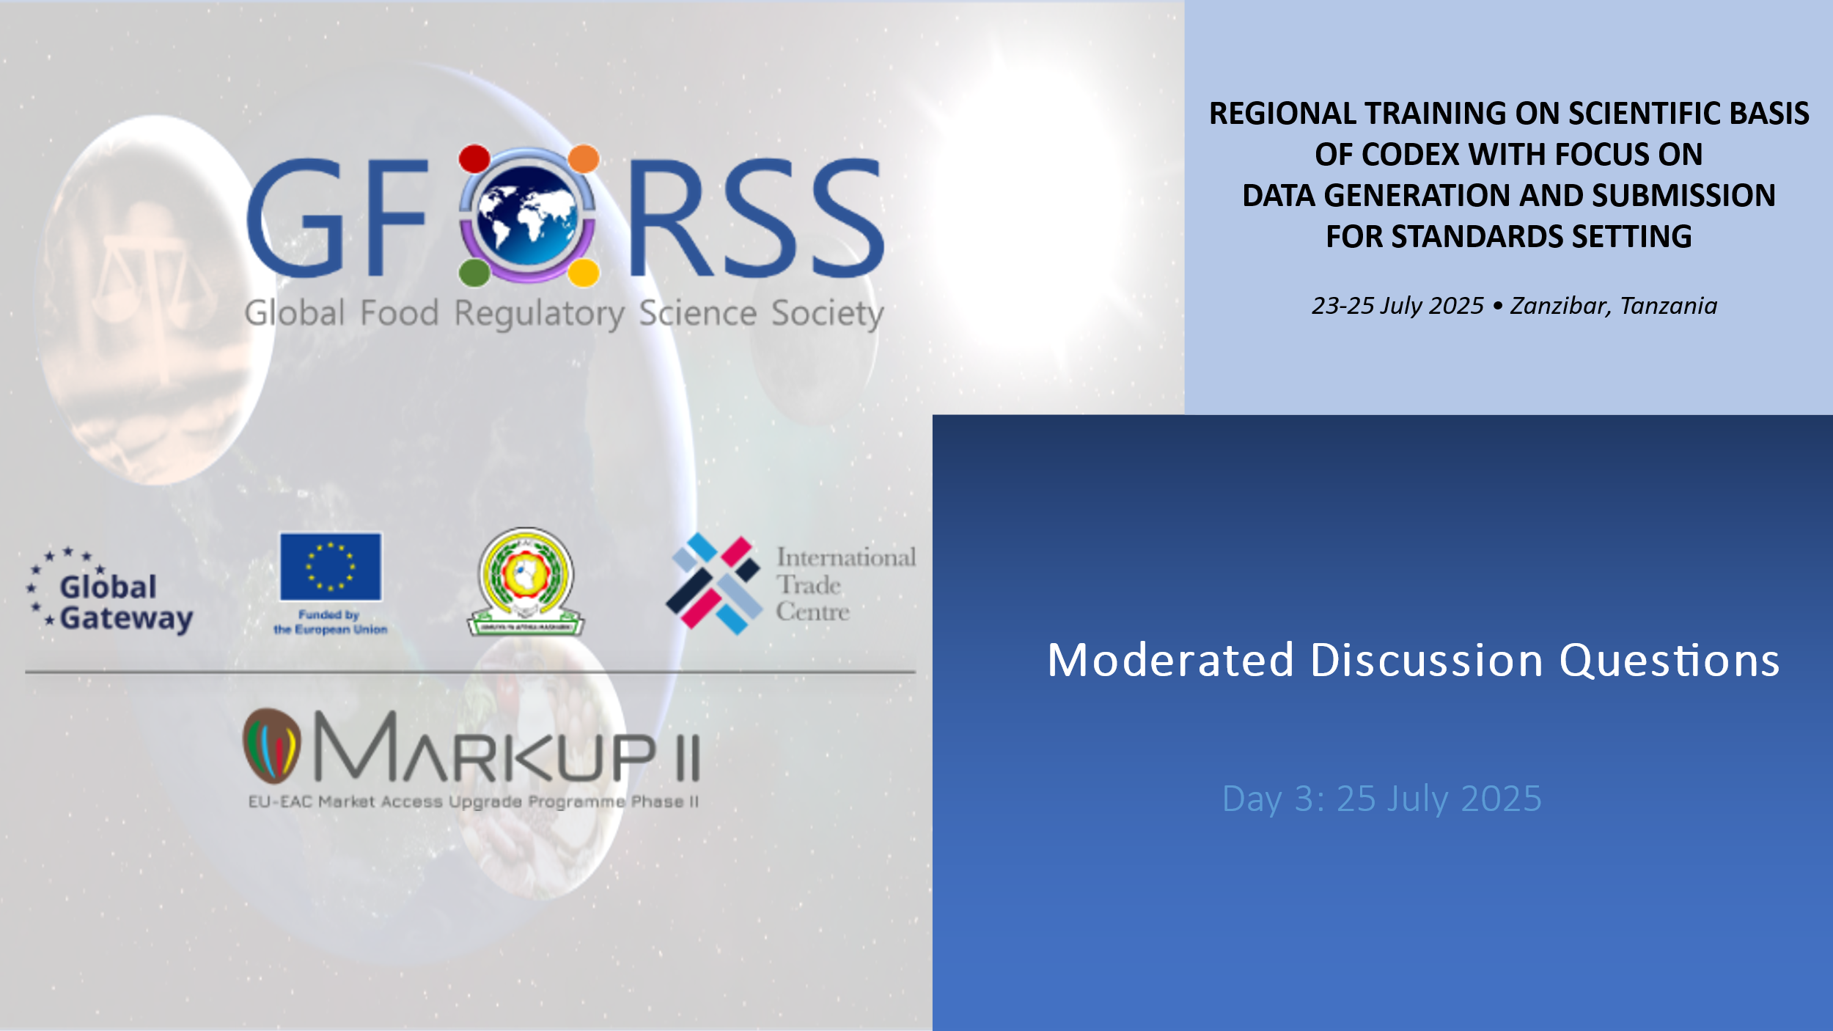

# A. Options to Develop, Analyse and Prepare Data for Submission

1. What types of national or regional data (e.g., monitoring data, Total Diet Studies, consumption surveys) are currently available in your country / region that could be leveraged for Codex submissions?

Click or tap here to enter text.

1. What are the key criteria that determine the acceptability of data for Codex use? How can we ensure our data meets those standards?

Click or tap here to enter text.

1. Which institutions (laboratories, academia, regulators) in your country / in the EAC are best placed to lead or support data collection and preparation for Codex purposes?

Click or tap here to enter text.

1. What tools or platforms (e.g., GEMS/Food) have you used or could be used to support data formatting and submission to Codex?

Click or tap here to enter text.

1. How can data collected for national purposes be repurposed or repackaged to support Codex standard-setting?

Click or tap here to enter text.

# B. Identification of Mitigation Solutions for Lack of Data

1. When key data are missing (e.g., food consumption data, contaminant occurrence data), what interim solutions can be used to support Codex positions or participate in risk assessments?

Click or tap here to enter text.

1. Are there regional data-sharing mechanisms or intra-African collaborations that could help bridge data gaps in the EAC region?

Click or tap here to enter text.

1. What are examples of low-resource approaches that can help generate indicative data to inform Codex discussions?

Click or tap here to enter text.

1. How can stakeholders (e.g., private sector, research institutions) be engaged to help fill data gaps?

Click or tap here to enter text.

1. In what ways can we rely on modeled or extrapolated data (e.g., regional estimates) responsibly when local data are absent?

Click or tap here to enter text.

# C. Identification of Milestones to Build Capacity to Address Data Calls by Codex

1. What are short-, medium-, and long-term steps that your country can take to improve readiness to respond to Codex calls for data?

Click or tap here to enter text.

1. Which capacities (technical, institutional, financial) are currently limiting your ability to respond to Codex data needs, and what milestones could be set to overcome these?

Click or tap here to enter text.

1. What training or resources are most needed to strengthen your national/regional system for Codex data support?

Click or tap here to enter text.

1. How can regional platforms or EAC coordination mechanisms be leveraged to streamline capacity-building and collective data contributions to Codex?

Click or tap here to enter text.

1. What would an effective national roadmap to improve data contribution to Codex look like, and who should lead its development?

Click or tap here to enter text.

1. Suggestion from EAC: What are the other areas of food risk analysis that warrant more attention for capacity building purposes (such as those related to microbial and nutritional matters) how do you suggest to address those gaps ?

Click or tap here to enter text.

# D. Negotiation Skills and Advocacy for Support to Data-Related Activities

Negotiation & Position Development

1. How can we better integrate scientific data into our national Codex delegation positions during committee negotiations?

Click or tap here to enter text.

1. What negotiation skills are needed to advocate for your country’s context when data are limited or when assumptions may not reflect your national reality?

Click or tap here to enter text.

1. How can scientific experts (e.g., from labs or academia) be better included in national Codex delegations to support data-driven negotiation positions?

Click or tap here to enter text.

1. In what ways can countries strengthen their ability to influence Codex outcomes when they contribute valuable data?

Click or tap here to enter text.

Advocacy & Resource Mobilization

1. What mechanisms or channels (e.g., ministries, donors, regional bodies) can be used to advocate for more investment in Codex-relevant data generation?

Click or tap here to enter text.

1. What role can the private sector and industry associations play in co-investing or supporting data collection for Codex submissions?

Click or tap here to enter text.

1. How can countries make the case to political decision-makers that investment in data generation supports international trade and food safety?

Click or tap here to enter text.

1. Are there regional funding opportunities or partnerships (e.g., AU, ITC, development partners) that can be tapped into to support data-related activities?

Click or tap here to enter text.

1. What would a compelling business case or advocacy message look like to secure more funding for national data systems that respond to Codex needs?

Click or tap here to enter text.